Odirile Masemola

WEDE PART 1-2

ST10441421

Contents

Homepage Improvements 3

Blog page improvements 5

Thee Shinobi, founded by Linda Hlongwane in Soweto, is more than just a clothing brand – it’s a movement uniting fashion across generations. As the brand continues to grow in popularity, launching a dedicated website is an important next step for several reasons.

Firstly, a website allows Thee Shinobi to expand beyond its current local reach. While it’s already gaining attention outside of Soweto, a well-designed website can provide access to national and even global customers. People from across the world can browse and purchase items from the comfort of their homes. This broadens the customer base significantly, increasing brand visibility.

Secondly, a website can serve as an online store, boosting sales by allowing customers to purchase items at any time. By integrating e-commerce features, the brand can make its clothing and accessories available 24/7, without being limited by physical store hours. Additionally, online promotions, discounts, and exclusive web offers can attract more customers, improving revenue.

Moreover, having a website enhances The Shinobi’s brand image. A professionally designed website reflects the brand's identity, offering an authentic experience of its street-smart, modern vibe. Through high-quality product photos, customer reviews, and a blog featuring the brand’s story and vision, The Shinobi can build trust and loyalty with its audience.

In conclusion, building a website for Thee Shinobi is not just a smart business move, but a necessary step in the brand’s evolution. It opens the door to wider markets, boosts sales through online shopping, and strengthens brand credibility. A website will propel Thee Shinobi into the global fashion spotlight, reflecting its unique style and forward-thinking approach.

In addition to these benefits, a website allows for better customer engagement. Features like newsletters, customer accounts, and social media integration can help Thee Shinobi build a loyal community. It also provides valuable insights through analytics, helping the brand understand customer preferences and optimize its marketing strategies for even better sales growth

# Changes to part 1

# Homepage Improvements

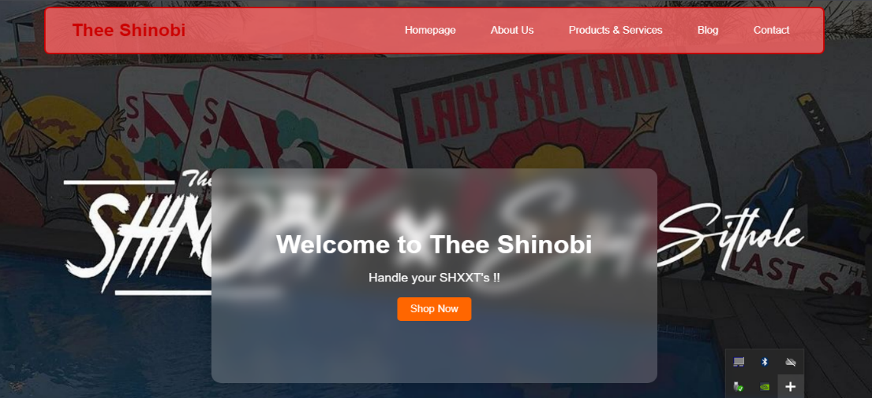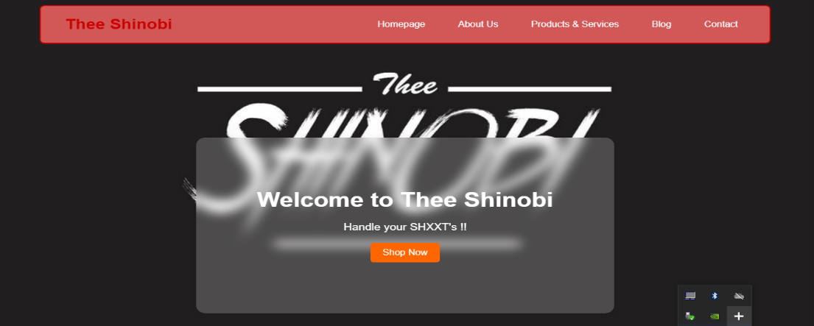For the homepage first changed my background image from the picture in figure 1 to the one in figure 2

Figure 2

Figure 1

I also changed my homepage code for:

* Accessibility Enhancements: Added role="banner", role="navigation", role="region", and role="contentinfo" to improve screen reader support.
* Cleaned HTML Structure: Properly closed the div inside the hero section for the .text-box.
* Corrected Content: Updated some links for consistency (e.g., "Products & Services" instead of "Products and Services").
* Readable Code: Improved indentation for better readability.

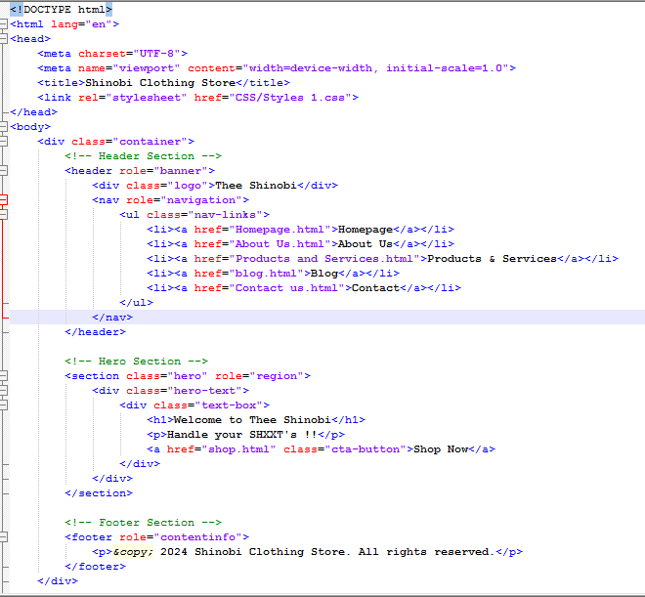Here is my new Homepage code

# Blog page improvements

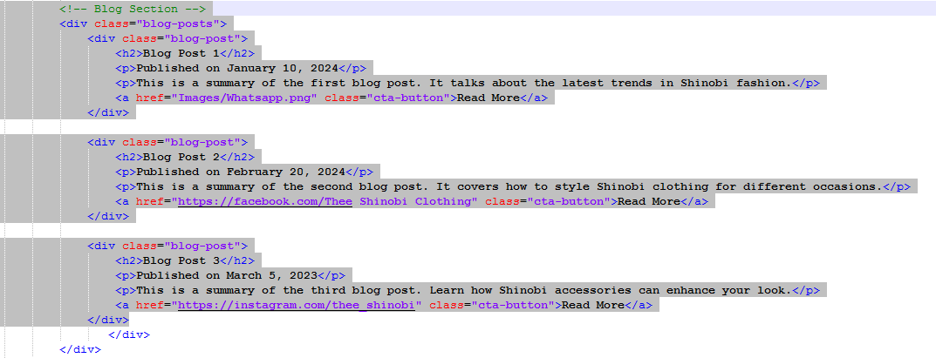I added images to my blog page for improvement and also fixed my buttons to redirect you to the original post on the social media platforms. This picture below is my code for part 1 before I added images and fixed the button link

Part

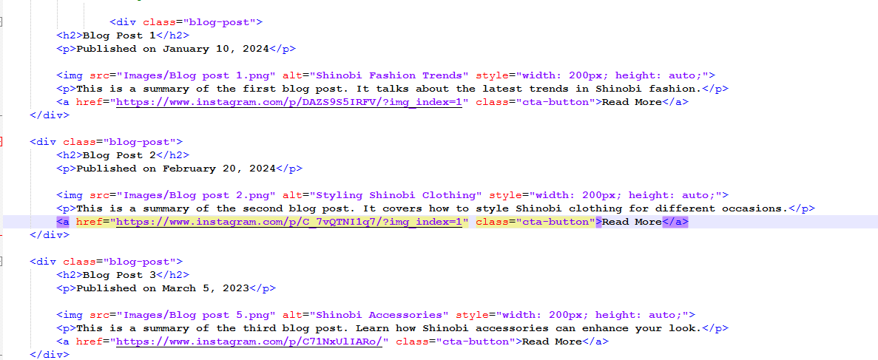The code below shows the complete one with images and fixed links

Part

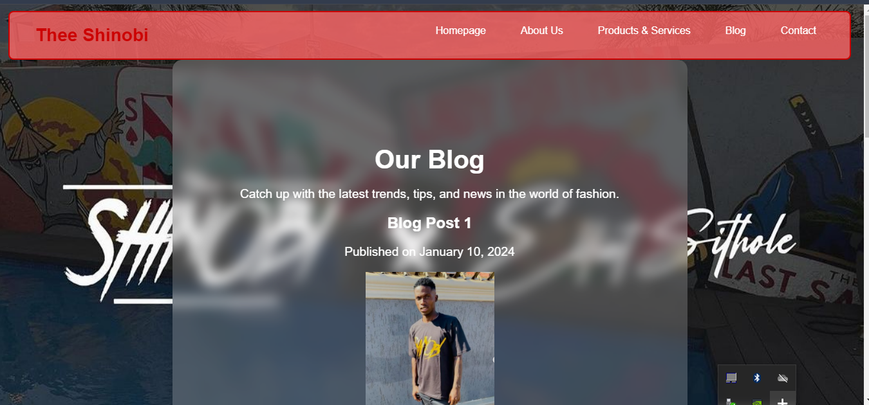This is how my blog page looks like after changes

I fixed a few issues I had with the shop page navigation system so that it is also able to navigate properly.

I’ve also linked my pages to CSS and also to JS.